**How data is flowing End-to-End from Pentaho -> MySQL -> SoapUI.**

**Steps of CSV file loading from Pentaho to Database:**

1. The below attached screen shot of Pentaho which was about start.

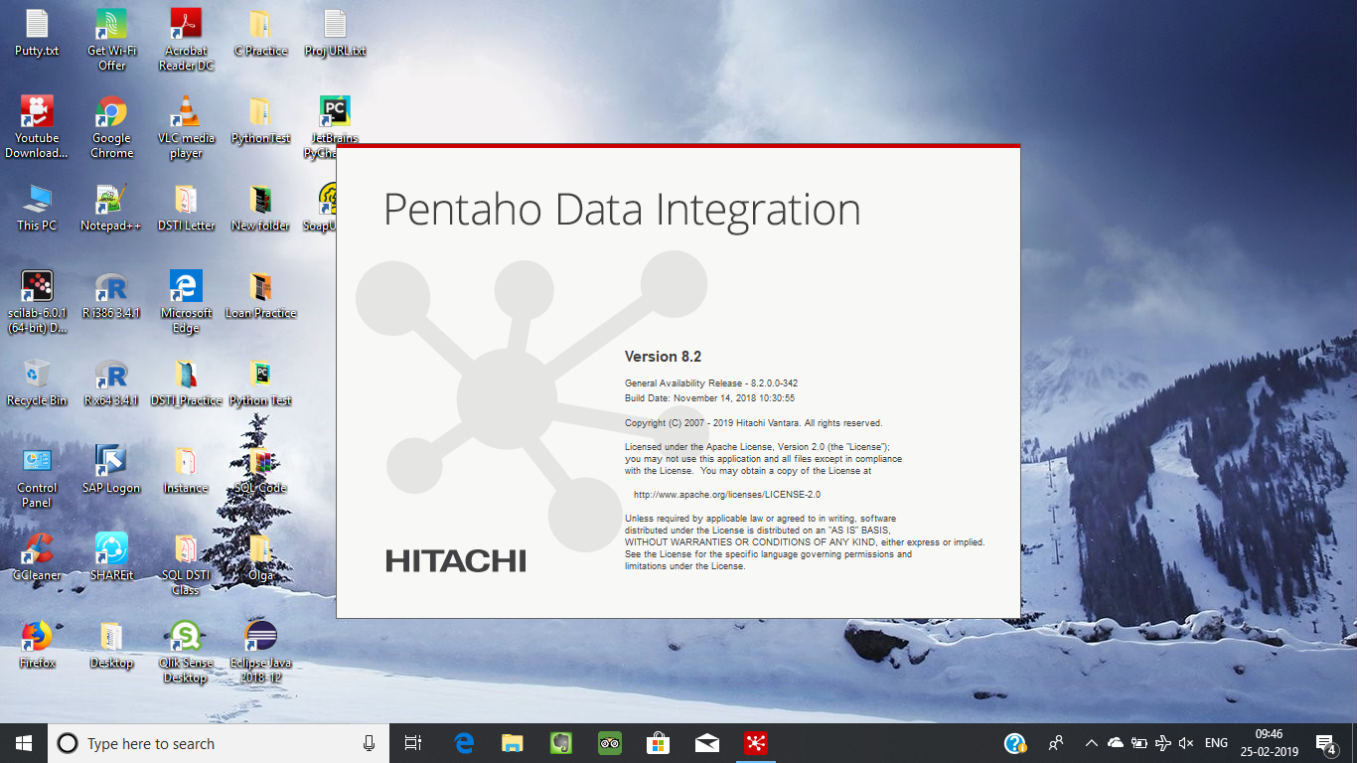

1. This below screen describes the front page of Pentaho which contains two parts i.e., left handed side screen contains Transformation and Jobs and Right handed Side contains welcome Screen.

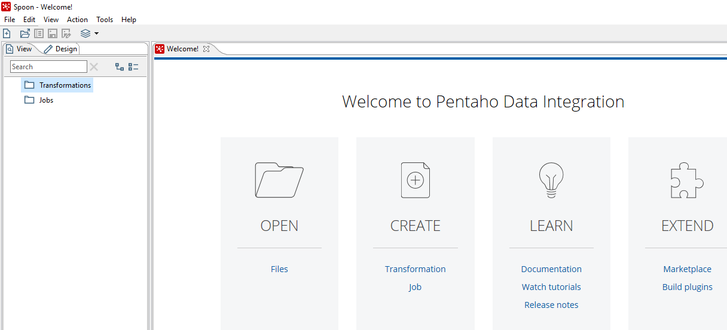

1. After double clicking on Transformation button, the following screen will be opened and this screen contains those mentioned following folders i.e., **Input, Output, Streaming, Transform, Data warehouse** etc.

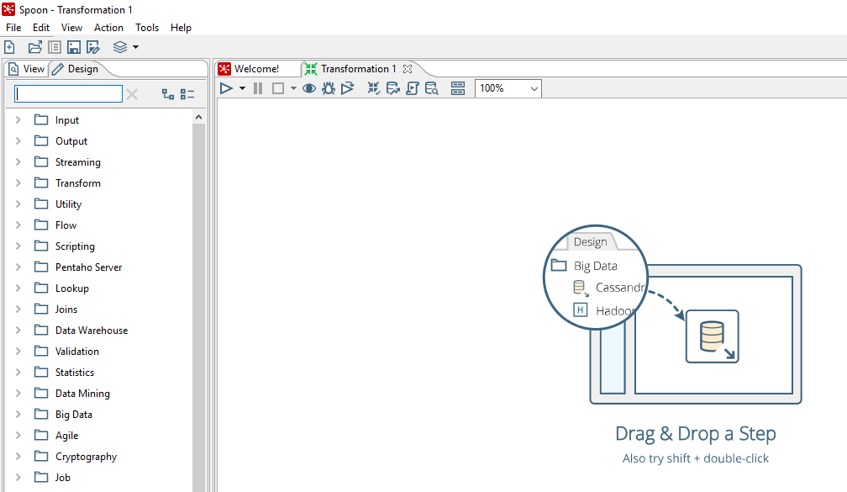

1. Click on Input folder, then there are few descriptions will be populated as shown in the attached screen shot. And, drag the CSV file Input to right side dashboard (**Transformation window**) as shown in the below screen shot.

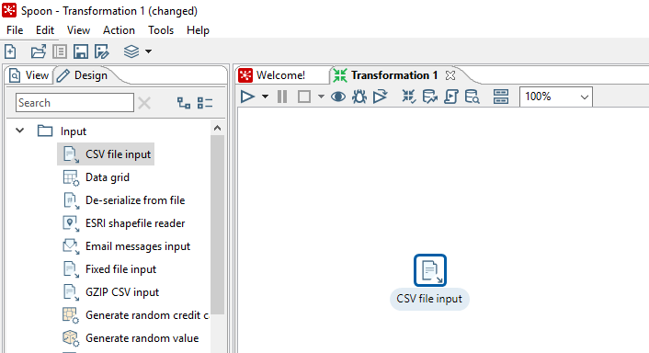

1. Double-click on the CSV Input step to view its properties. Change the name of the step to “**Retail CSV File Input**” as shown below:

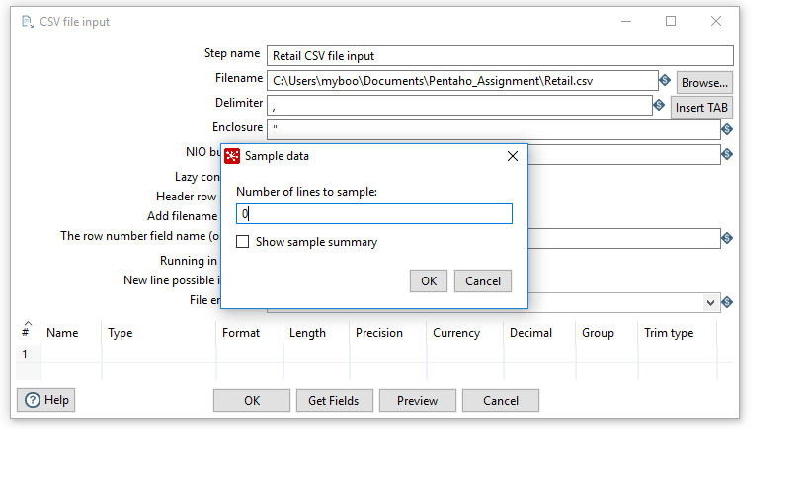

1. After importing CSV file, getting these many variables along with data type and many more. The tester or Dev can modify the below parameters as per their requirement.

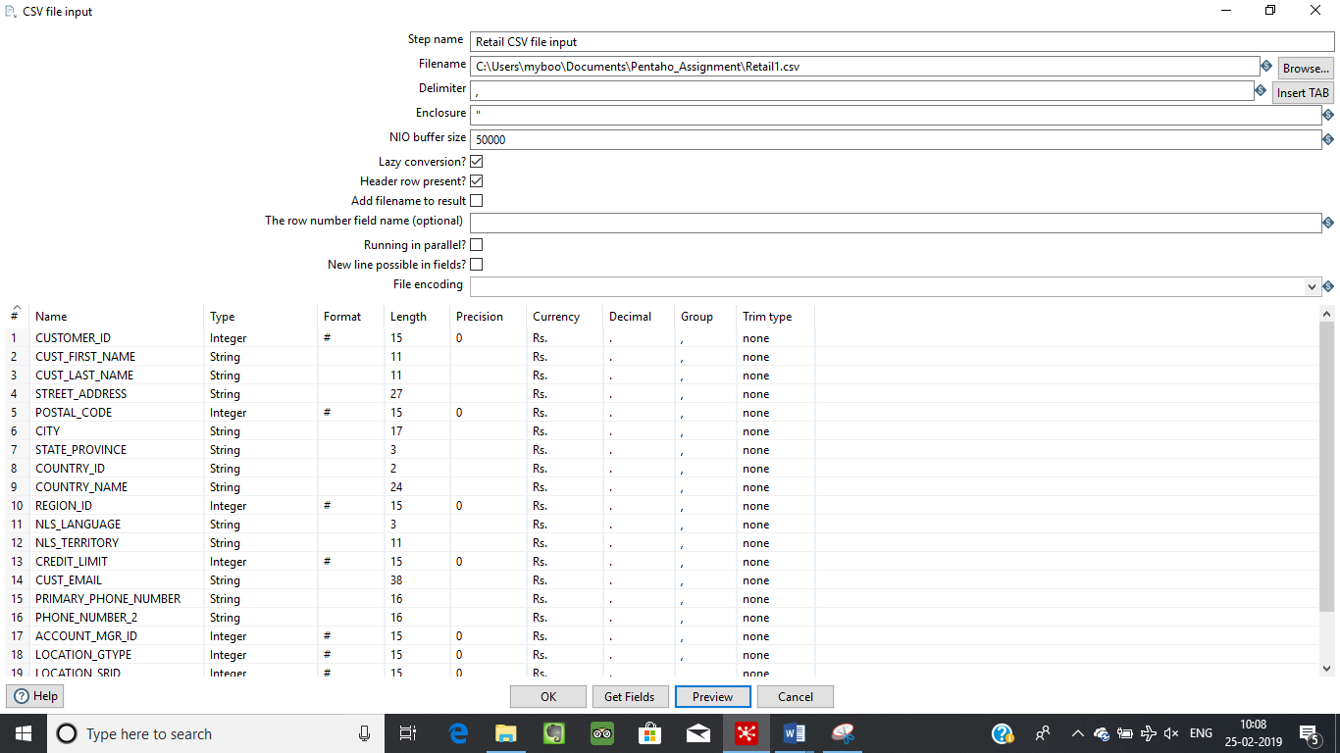

1. The below mentioned screen shot is showing records which are coming from the CSV file.

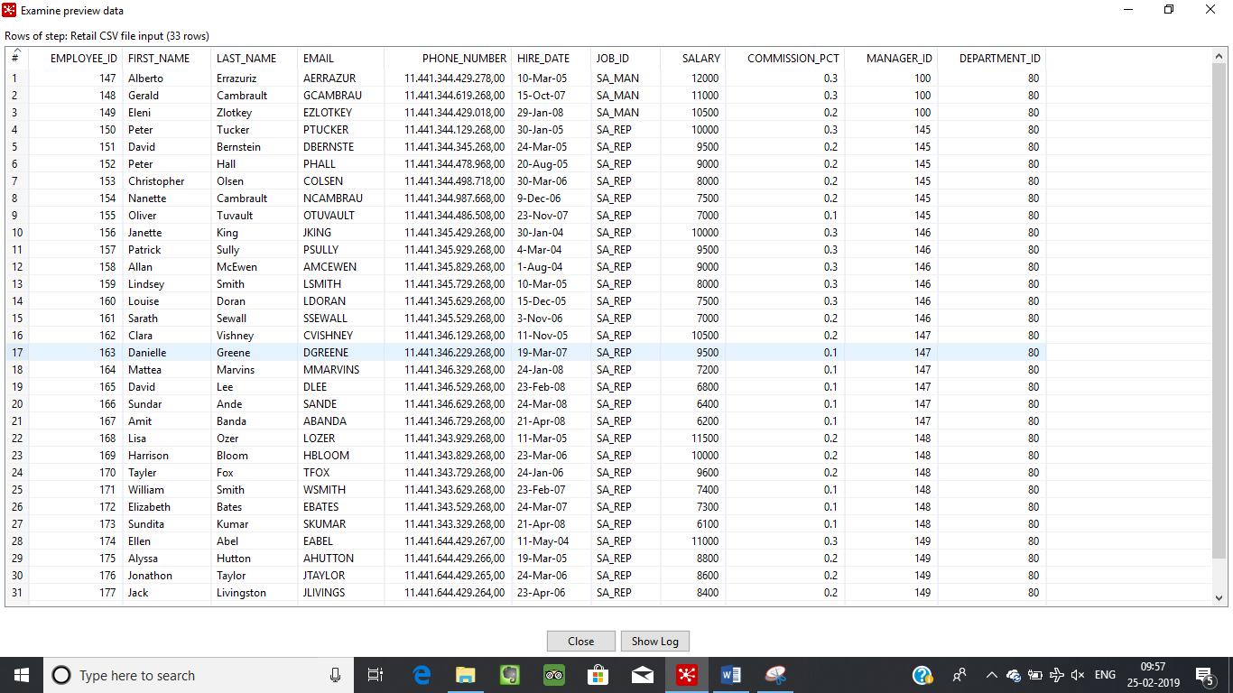

1. The Dev or QA needs to verify that the data is accurately imported into Pentaho system or not. That’s why, the following Retail. CSV’s records screen shot. As a result, we can easily verify to this data with Pentaho. Both screen shots are verified with this screen shot that records are fetched accurately from CSV to Pentaho system.

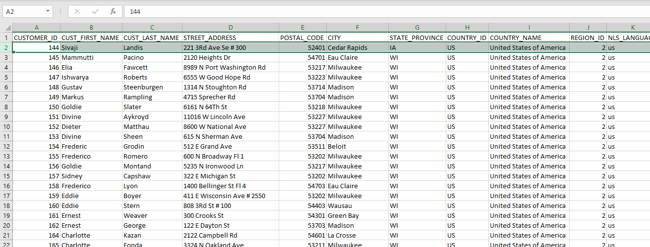

1. Creating a dimension lookup step. Close up the Inputs folder and open the **Data Warehousing** folder. Drag and drop the Dimension Lookup/Update transformation step to the transformation window.

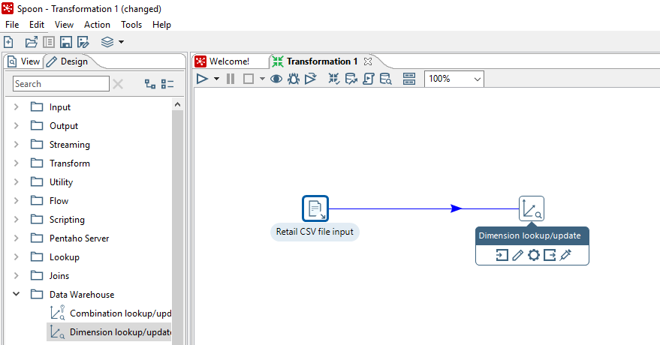

1. Making name of this Step name.

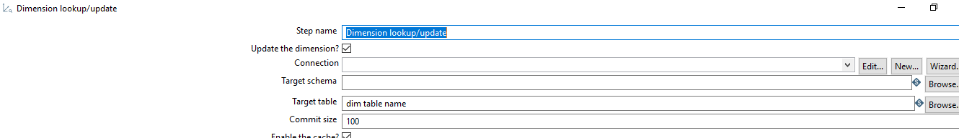

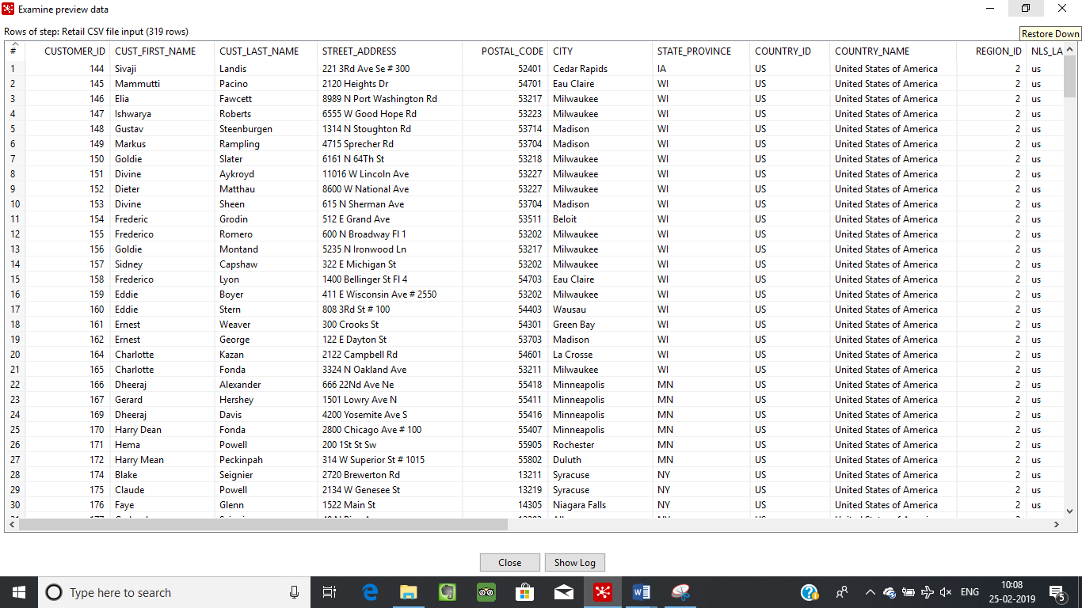

1. Creating a connection between Pentaho and mysql database and browse the Target table name and connect to mysql db for the data load and Click on SQL button to load data into database.

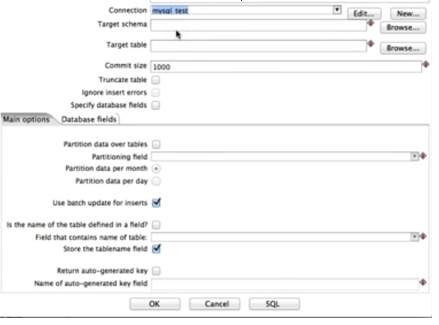

1. If everything is well and good then connection will be established and also test the connection. Records will be populated in the mysql db(satip)->table(Retail). Here is the below attached screen shot with data.

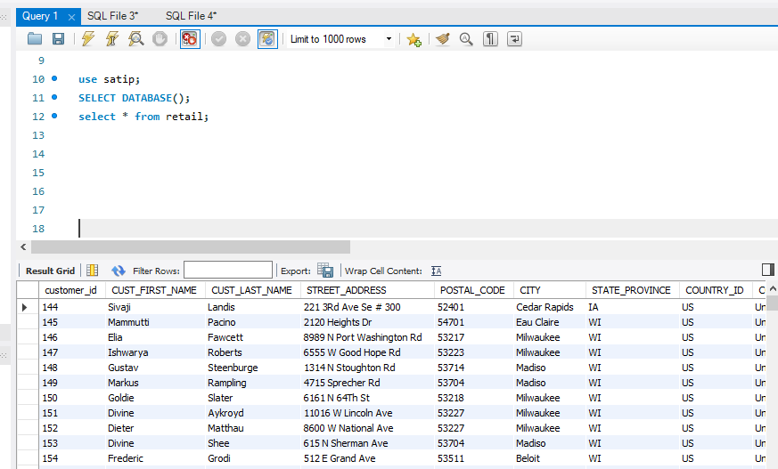

**Note:**

Records are extracted from CSV file using Pentaho analytical tool and loading records in Mysql table i.e., satip.Retail.

Now need to extract those records from Mysql table using SOAPUI tool as mentioned below.

**Using SOAPUI**

1. The below attached launching screen shot of SoapUI i.e.,

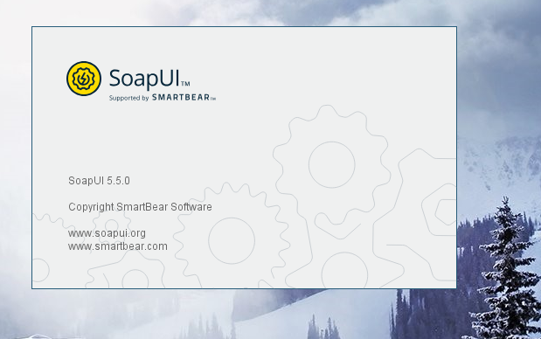

1. Before building the connection between SoapUI and Mysql db, need to create a TestSuite -> TestCases -> TestSteps -> JDBC Connection.

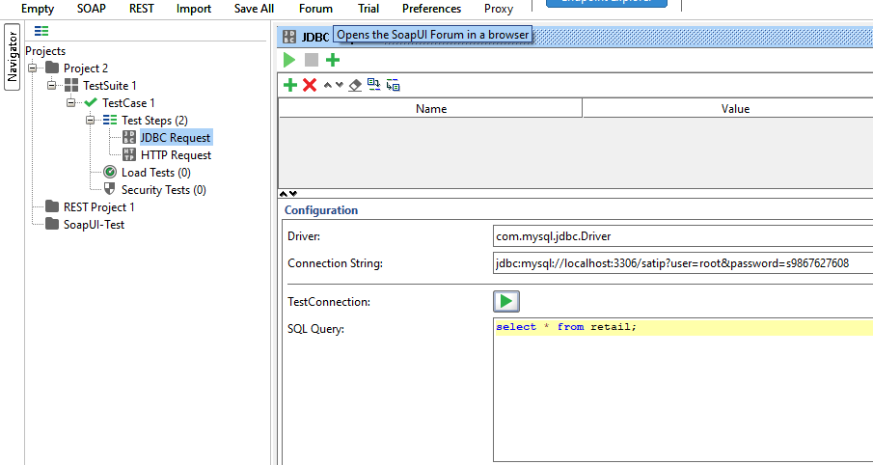

1. This is first picture of the SoapUI as shown below.

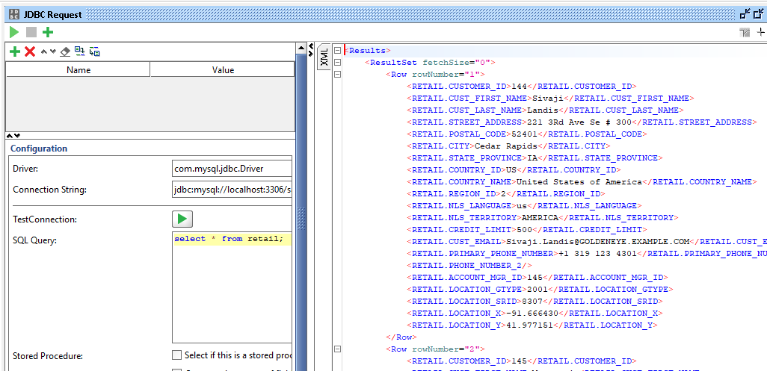

1. The below attached screen shot of Mysql database side as a proof from database point of view.

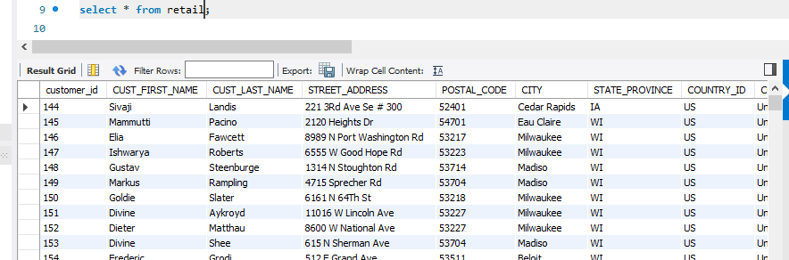

1. Also, attaching the screen shot of CSV file where I took data and worked on end to end activity to produce XML output in SoapUI.

